Summer Math
for Incoming Fifth Graders

This summer, students will earn their first two grades for math as fifth graders.

PART I (15 point assignment): is a leveled math review book available in major retailers and on Amazon.com for $3.99. Students should complete every third page (multiples of 3 (pg, 3, pg 6, pg. 9, pg 12, pg. 15, 18, etc.) This should be handed in the first week of school.

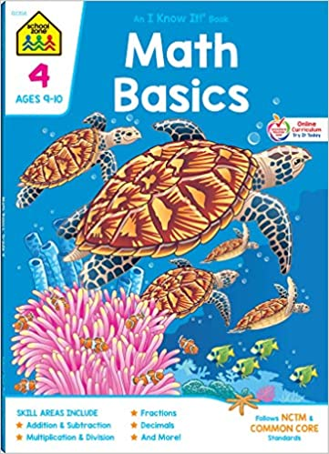

ISBN #: 978-0887431401

PART II: (10 point assignment):

Students should also choose six weeks to practice multiplication and division facts. (15 min. per day, 4 days per week). Math fact practice logs are attached and should be handed in when school resumes in the fall. Fact practice can include a parent quizzing a child, an online program such as multiplication.com, hooda math or mathisfun.com or any other method that allows a student to review math facts.Please have a parent or caregiver sign each practice log. Practice logs may be split up over weeks as long as the student has six weeks worth of practice accounted for.

