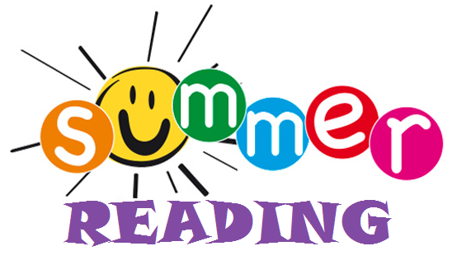
2024-2024

Summer Reading has officially started!

We believe that summer is a crucial time to keep our students engaged in learning and to prevent the “summer slide”. The summer slide can be avoided by ensuring that children are as engaged as possible in whatever they choose to read — just as long as they are reading.

Students entering third grade are required to read one book and complete a book report from the choice board. They are also required to choose one additional book. You may add any other books you read over the summer to the Reading Log. That is optional.

Required Book: Read Third Grade Angels by Jerry Spinell and then choose a book report option from the choice board to compete.

Choose 1 other book from this list. Fill out the reading log for the chosen book and any other books read over the summer.
- Mr. Popper’s Penguins by Richard and Florence Atwater -Freckle Juice by Judy Blume
- Ralph S. Mouse by Beverly Cleary -Fantastic Mr. Fox by Roald Dahl
- A-Z Mysteries Books by Ron Roy -My Father’s Dragon by Ruth Stiles Gannet
- Cam Jansen Books by David A Adler -Horrible Harry Books by Suzy Kline

