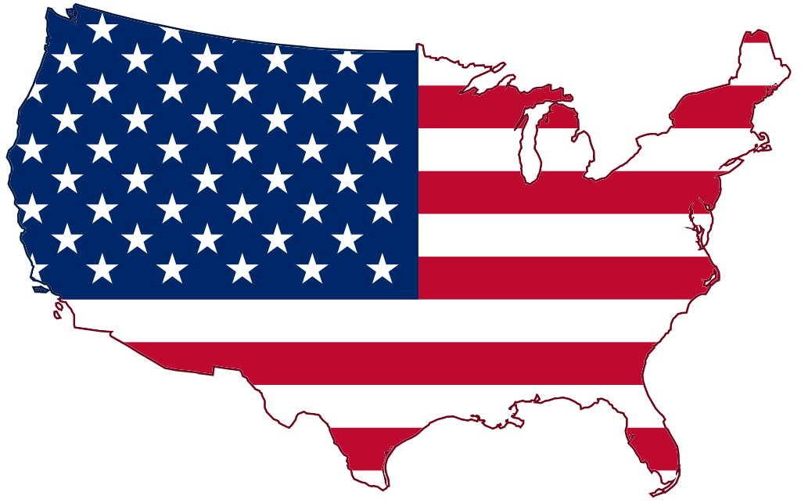
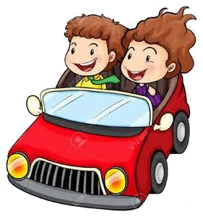

Summer READ Trip:
Three Book Challenge!

A fun, engaging way to get students reading AND learn about the places, people, and events of the USA!

Summer READ Trip: Three Book Challenge!
Rules:
Your Summer READ Trip is an opportunity to learn about our wonderful country...and read some great books along the way! In order to begin your trip you must select a state on the map provided, read a book from the assigned genre, and complete the activities. Each state has been assigned a genre. For a book to count it should be a good level for you, not too hard and not too easy.
Once you have read a book, then you must complete a Book Report for that book, and have a Book Talk with a parent or another adult. After you have given your Book Talk, your parent or adult will sign off on your Book Report. The final step is to color in that state on your map. You are all finished with that destination and you can start the whole process over again.
You are able to choose your route across the country, but you may only visit a state one time throughout the summer. Your goal is to visit three states during the summer.
Side Trips:
Throughout the summer break, at least one Side Trip must be completed. Side Trips are a chance to learn about places of interest (such as a national park or historical site), famous people, or important events that have impacted or influenced our nation. To receive credit for a Side Trip, you must complete some form of a nonfiction response about your person (Abraham Lincoln, Harriet Tubman, etc.), place (Grand Canyon, Mount Rushmore, etc.), or event (American Revolution, Louisiana Purchase, etc.). This may also require you to gather some additional information from a nonfiction text or website. Your Side Trip piece of writing should include important information and details, as well as an explanation why you chose that person, place, or event. Side Trip options include travel brochure, poem, digital presentation, poster, postcard, or any other idea to demonstrate your learning!

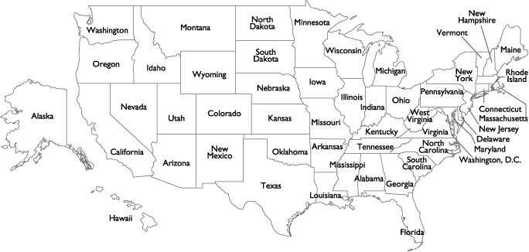
Summer READ Trip Map-Three Book Challenge

State | Genre | State | Genre
Alabama | Adventure | Montana | Adventure
Alaska | Biography | Nebraska | Biography
Arizona | Award Winner | Nevada | Award Winner
Arkansas | Historical Fiction | New Hampshire | Historical Fiction
California | Fantasy | New Jersey | Fantasy
Colorado | Book Made into Movie | New Mexico | Book Made into Movie
Connecticut | Non Fiction | New York | Non Fiction
Delaware | Classic | North Carolina | Classic
Florida | Humorous | North Dakota | Humorous
Georgia | Realistic Fiction | Ohio | Realistic Fiction
Hawaii | Historical Non Fiction | Oklahoma | Historical Non Fiction
Idaho | Picture Book | Oregon | Picture Book
Illinois | Sports or Hobby | Pennsylvania | Sports or Hobby
Indiana | Fiction | Rhode Island | Fiction
Iowa | Mystery | South Carolina | Mystery
Kansas | Book From a Series | South Dakota | Book From a Series
Kentucky | Parent/Adult Choice | Tennessee | Parent/Adult Choice
Louisiana | Science Fiction | Texas | Science Fiction
Maine | Nature | Utah | Nature
Maryland | Poetry | Vermont | Poetry
Massachusetts | Science Fiction | Virginia | Science Fiction
Michigan | Drama | Washington | Drama
Minnesota | Multicultural | West Virginia | Multicultural
Mississippi | Autobiography | Wisconsin | Autobiography
Missouri | Free Choice | Wyoming | Free Choice

‘s Summer READ Trip Reading Log

Date | Title of Book |  | TH/TE/JR | F/NF | Genre |  | Page Started & Ended | Minutes Read | Finished Book (Y/N) | Reading Engagement Level | Parent Initials
 | TH = Too Hard | TE = Too Easy |  | JR = Just Right |  | F = Fiction |  | NF = Non Ficti on

Summer READ Trip Book Report by: Date: Title: Author: Number of Pages: Genre: State:
Setting: Where and when does your story take place?
Where: When:
Characters: Who are the characters in your story?

Fiction--Plot: Describe the main events from your book in the Flow Map.
Non-Fiction--New Learnings: What are three new facts you learned from this book?
Beginning/New Fact #1:

↓
Middle/New Fact #2:
↓
End/New Fact #3:
New Vocabulary: Choose and define two new words from your book.
Word: Page: Definition:

Favorite Scene: Illustrate your favorite scene and add a caption.
Text Connection: Make a Text-to-Text, Text-to-Self, or Text-to-World Connection. (I thought it was interesting that… OR … reminds me of …)
Theme: What do you think the author’s theme (message) is?
Rating: On a scale of 1 (couldn't stand it) to 10 (LOVED it!), rate your book.
Recommendation: Would you recommend this book to a friend? Explain.
Parent Initials for  Book Talk: | Date Completed: | Teacher Initials for  Book Report Credit:

