EASY WAYS TO HELP OUR SCHOOL

Here are 3 easy ways to help raise money for our school. We are hoping that everyone can register for at least one if not all of these. Your per person donation may look small but if everyone participates it can equate to over $1000 for our school in a year. Anyone can participate so let your friends and family know. Please lend a hand!

Harris Teeter
Shop at Harris Teeter and use your VIC card to earn cash for our school. Your card needs to be relinked every August so if you participated in the past please relink your card. Here is how:
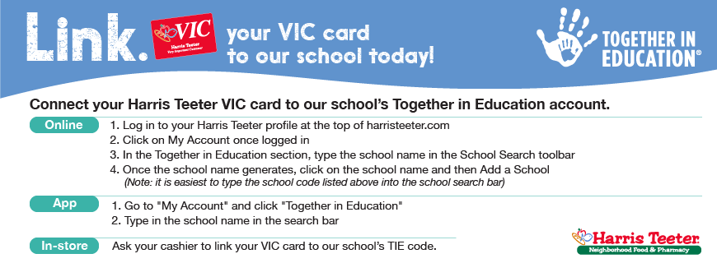
Box Tops for Education
Box tops for Education has gone digital! Download the app to your phone, look for our school by zip code and scan your receipts. We will not be accepting clipped box tops this year.
Amazon Smile
Shop at AmazonSmile and select St. Casimir Church Baltimore as your charitable organization - Amazon will donate directly to St. Casimir School!
- Amazon donates 0.5% of the price of your eligible AmazonSmile purchases to the charitable organization of your choice – select St. Casimir!
- AmazonSmile is the same Amazon you know. Same products, prices and service.

