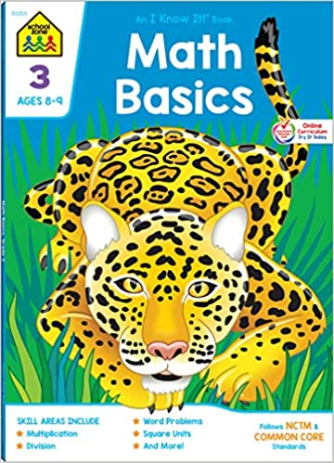
Summer Math for Incoming Fourth Grade This summer, students will earn their first two grades for math as fourth graders.

Summer math REQUIRED WORK is a leveled math review book available in major retailers and on Amazon.com for $3.99. The title is Math Basics, Grade 3, ISBN: 10: 0887431399. Students should complete at least 15 pages to help them review math concepts and computations. This should be handed in the first week of school.
Next, students need to practice addition, subtraction, multiplication, and division math facts. If you do not have flash cards, you can purchase them at the Dollar Store, Walmart, Target, etc.
Addition/Subtraction/Multiplication/Division Practice:
Students should also choose six weeks to practice addition, subtraction, multiplication and division facts. (15 minutes per day, 4 days a week). Math fact practice logs are attached and should be handed in when school resumes in the fall. Fact practice can include a parent quizzing a child, an online program such as multiplication.com, hooda math, or mathisfun.com or any other method that allows a student to review math facts. *Students must come to school being familiar with their times tables up to 12.
Please have a parent or caregiver sign each practice log. Practice logs may be split up over weeks as long as the student has 6 weeks of practice accounted for.

SUMMER READING FOR
STUDENTS ENTERING 4TH GRADE
Students entering 4th grade will be required to read TWO (2) books this summer. The first is a novel that should be chosen from the list below. The second should be a nonfiction selection of their choosing. It is highly recommended that your child spend at least 15 minutes a day reading throughout the summer.
- Required Fiction Novels:
Novels: (choose one)
Paint the Wind by Pam Munoz Ryan
The Indian in the Cupboard by Lynne Reid Banks
James and the Giant Peach by Roald Dahl
Stuart Little by E.B. White
Mr. Popper’s Penguins by Richard Atwater
The Magical Ms. Plum by Bonny Becker
Nate the Great by Marjorie Weinman Sharmat
Owen Foote, Super Spy by Stephanie Greene
Carnival at Candlelight by Mary Pope Osborne
Casey at the Bat by Patricia Palacco
Ramona the Brave by Beverly Cleary
A-Z Mysteries book from the series by Ron Ray
Judy Moody was in a Mood by Megan McDonald
Little House in the Big Woods by Laura Ingalls Wilder
Freckle Juice by Judy Bloom

For the Fiction Novel:
Directions:
Choose one of the books from the list. After reading it, you should draw a Comic Strip including at least 5 boxes that include the beginning, 3 middle events, and the ending of the story. Please include a description of the event and some talk bubbles.
List the Title of the Book, the Author, and the Reading Level.
All written work must be neat, legible and done in cursive.
Make sure your first and last name are on your paper.
Work should be done on white paper and should be lined if necessary.
Any illustrations should be neat, detailed, and colored.
Have fun!!!!!
For the Nonfiction Book:
Directions:
Please select a nonfiction book of your choosing.
Choose a topic of interest to you or choose something you want to learn more about.
After reading this nonfiction book, complete the attached Non-Fiction Book Report.
Thank You!

