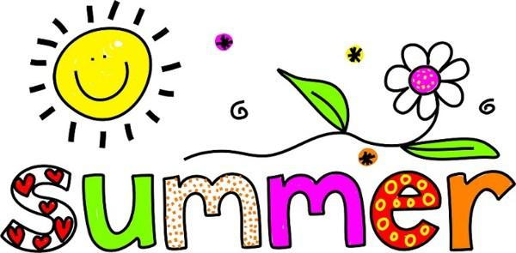
Summer Reading and Math

Dear Incoming Kindergarteners & Parents,
Congratulations on completing PreSchool and WELCOME TO KINDERGARTEN! Your first job as a rising Kindergarten student is to complete some summer activities to keep skills sharp. So, here is your first Kindergarten assignment!
Reading- Please “read” 10 books over the summer. Look for books that rhyme, books with numbers or letters or just a delightful story full of fun characters and settings. The attached link will bring you to a list of books that you may like to consider but use your own discretion and choose books that you love, or books that you find interesting and fun.
Math- Please purchase a Kindergarten Readiness Math Workbook- books should address numbers, number writing, counting sets and early addition and/or subtraction skills. Books can be purchased at Lakeshore Learning, Barnes & Noble, Ollie’s, Amazon, Target, etc. Again, I have provided a link to a book that you can use and some suggestions for others as well.
Have a great summer! Can’t wait to see you at Cubby Conferences!
Mrs. Melanie Conley &
Ms. Claudia Lohr
>>>>>>>>>>>>>>>>>>>>>>>>>>>>>>>>>>>>>>>>>>>>>>>>>>>>>>>>>>>>>>>>>>>>>>>>>>>>>>>>>>>>>>>>>>>
Reading- Good Reads lists appropriate titles for Kindergarten students. Ask your librarian for some “goodreads” or check out Epic.com
Math-these links will take you to an appropriate resource but feel free to find your own-
PreSchool Math Prek Math Practice PreSchool Math Workbook
Also on Amazon- School Zone, Transition Math Workbooks K-1- there are several choices and these include money and time which you do not need at this time. $2.79-$3.99
Other suggestions- Active Minds: 101 Things to Know About Math- Publications International, Ltd.
ISBN: 978-1-4508-5094-0
____________’s Summer Reading Log
Name
 | Title | Author | Rating
1
2
3
4
5
6
7
8
9
10

