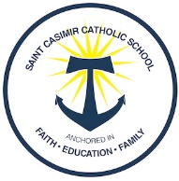
Legacy Project Grant Application

Student’s Name ___________________________________________ Grade ______
School year in which you are applying for _______________________
- I have completely filled out St. Casimir Catholic School Application or I am planning to re-enroll my student. Yes or No

- I have completely filled out a FACTS Financial Aid Application. Yes or No

- I am requesting financial aid thru the State of Maryland and have filled out a BOOST Scholarship Application. Yes or No

I am interested in a Catholic Education for my child at St. Casimir Catholic School because:
______________________________________________________________________________________________________________________________________________________________________________________________________________________________________________________________________________________________________

Parent or Guardian Name(s) ______________________________________________
Signature(s) ___________________________________ Date___________________
Please email this completed form to admissions@stcasimirschool.us

