SAINT CASIMIR WEEKLY UPDATE
October 20,2020

Attached:
- Home School Association letter
- Turkey Trot flyer
- Charleston Wrap information
- Halloween form for virtual learners
- Spirit Wear flyer
______________________________________________________________
Thanks to all the families who sent in Halloween candy.

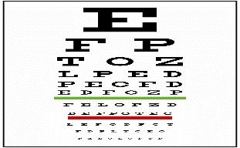Vision screening: Permission slips were sent home today to students in Kindergarten and Grades 3, 4, and 5 for vision screenings on November 16th and November 23rd. They will be screened through the Good Samaritan Hospital Outreach program. Thanks to Ms. Bekky for arranging this.

Room parents: Thank to all who have volunteered to be room parents.

Pre-k 3: Paige Odabashian
Pre-K 4: Kay O’Neil
K- Mrs. Mel: Michelle Pearce
K- Ms. Head: Angel Connoly
1: Kelly Meade, Janelle Lawrence
2: Jen DiMattina
4: Stephanie Bartomioli, Ivana Lalicki and Shannon Cos
5: Maria Gutierrez Hoffmann
6: Laura Gaba
7: Katie Norgaard
8; Chrissy Rizzotti and Jen Jaski
Looking for a room parent for Grade 3. Please contact Mrs. White if interested.

Reminder: Friday, October 30th is a half day.

