Summer Math for
4th Grade

This summer, students will earn their first two grades for math as fourth graders.

Summer math REQUIRED WORK is a leveled math review book available in major retailers and on Amozon.com for $3.99. The title is Math Basic, Grade 3, ISBN; 10: 0887431399. Students should complete at least 20 pages to help then review math concepts and computations. This should be handed in on the first day of school.

School Zone - Math Basics 3 Workbook - 64 Pages, Ages 8 to 9, 3rd Grade, Multiplication, Division, Word Problems, Place Value, Fractions, and More (School Zone I Know It! Workbook Series) Paperback – Illustrated, February 2, 2009.
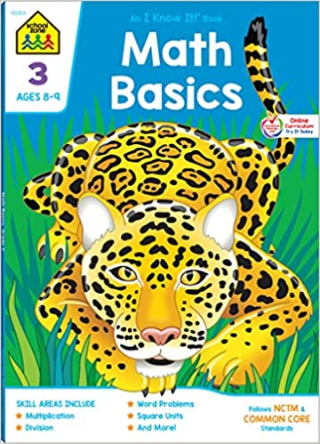Next, students need to practice addition, subtraction, multiplication, and division math facts. If you do not have flash cards, you can purchase them at the Dollar Store, Walmart, Target, etc. Students should also choose six (6) weeks to practice math facts (15 minutes a day, 4 days a week) and fill in and sign the math logs sheets. Fact practice can include a parent quizzing a child, an online program such as multiplication.com, hooda math, or mathisfun.com,or any other method that allows a student to review math facts. *Students should come to school being familiar with their times tables up to 12.
Please have a parent or caregiver sign each practice log. Practice logs may be split up over weeks as long as the student has six (6) weeks of practice accounted for.

