Summer Math for
4th Grade

This summer, students will earn their first two grades for math as fourth graders.

Summer math REQUIRED WORK is a leveled math review book available in major retailers and on Amozon.com for $3.99. The title is Math Basic, Grade 3, ISBN; 10: 0887431399. Students should complete at least 20 pages to help then review math concepts and computations. This should be handed in on the first day of school.

School Zone - Math Basics 3 Workbook - 64 Pages, Ages 8 to 9, 3rd Grade, Multiplication, Division, Word Problems, Place Value, Fractions, and More (School Zone I Know It! Workbook Series) Paperback – Illustrated, February 2, 2009.
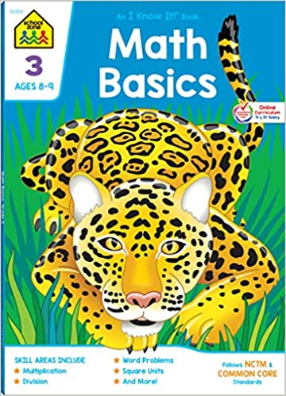

Next, students need to practice addition, subtraction, multiplication, and division math facts. If you do not have flash cards, you can purchase them at the Dollar Store, Walmart, Target, etc. Students should also choose six (6) weeks to practice math facts (15 minutes a day, 4 days a week).

Each student has an IXL account. On IXL, they can practice their Math Facts for addition, subtraction, multiplication and division.

*Students should come to school being familiar with their times tables up to 12.

Good luck!!!

