2020-2021 VOLUNTEER HOURS TRACKING

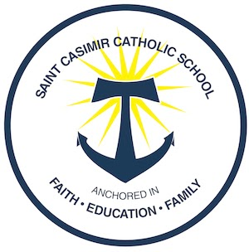

We love our volunteers and want to make sure you receive credit for your volunteer hours! Please use this form for tracking and email, scan, or send directly to the school office: kgirolami@stcasimirschool.us Thank you!

Name: __________________________________________________

Student(s) Names (s):_______________________________________

Grade (s):_______________________

Volunteer event:___________________________________________

Number of hours:_________________

Date:___________

