**September 16: Items to Come Home**

Please check your child's folder for the following items:

* **Snapology Flyer** – Grades Kindergarten & 1st Grade
* **Ukulele and Drum Flyer** – Pre-K 4, Kindergarten, Grades 1 & 2
* **Handbook Acknowledgement Form** – Grades 3–8

📘 **Handbook Link** [*https://stcasimirschool.us/wp-content/uploads/2025/09/2025-2026-Parent_Student-Handbook.docx.pdf*](https://stcasimirschool.us/wp-content/uploads/2025/09/2025-2026-Parent_Student-Handbook.docx.pdf)

* Purse Bingo Flyer

______________________________________________________________

* **Mass**
* The school Mass this Friday has been cancelled due to the funeral of Daryl Marczisewski (father of 3 of our graduates)

______________________________________________________________

The student council induction will take place Friday at 8:15

**Congratulations to our new Student Council members!**

We’re excited to share that they’ll be officially inducted this **Friday.**

President:  Kenzie Splitt

Vice president: Mai Ly Doucet Nguyen  
Secretary: Paige Purtell

Treasurer: Lexi Sticka

Class representatives:

Chloe Bailey

Vivienne Higley

Koryn Holmes

_____________________________________________________________

**Pasta Picnic:**

The Pasta Picnic still needs volunteers. Link below to volunteer.

[Pasta Volunteer Sign-up](https://www.signupgenius.com/go/4090F4EACAE22A6FE3-44869536-pasta#/)

______________________________________________________________

Purple Thursday

Students may dress in purple, black and ravens attire this Thursday.

_____________________________________________________________

**School Calendar Update**

In an effort to add another layer of protection and safety for our school community, our **online calendar of school events is now password protected**.

* 🔒 **Password:** Casimir2025!!  
   You should only need to enter the password once. You can **subscribe to the calendar** to receive automatic updates. Please contact us with any questions.

**Purse Bingo & HSA Designer Bag Raffle**

Get ready, – our fabulous **Purse Bingo** is back and better than ever!  
  **Save the Date:** **Friday, November 7th** Our Bingo Committee has been hard at work to make this an unforgettable night!

**Tickets** will be available soon—check your child's **Tuesday folder** in the coming weeks for all the details.

**Designer Bag Raffle** This year's raffle features a **Louis Vuitton Nano Madeleine purse** (Retail value: $2,230)!

* **Raffle Tickets:** $25 each
* **Purchase Online:**<https://ourschool.support/PurseBingo2025>
* **Winner Drawn at Purse Bingo** (Absentee winners can pick up their prize in the school office.)
* **See the bag in person** at Pasta’s Picnic!

Prayers for Mrs.Chorabik as she recovers from heart surgery. Mr. Motz will be teaching 7th Grade Religion and Ms. Pat will be teaching 6th grade Religion.

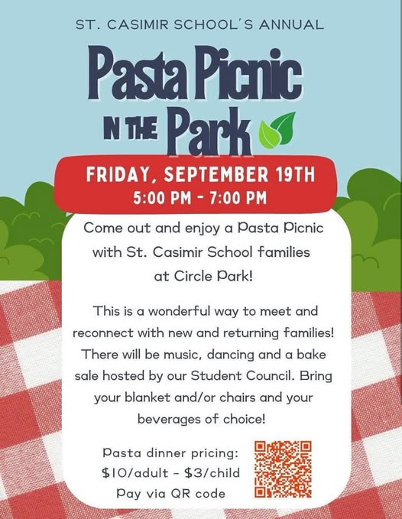



Last week's soccer highlights

*St. Casimir Soccer started the 2025 season off with a bang, netting 45 goals across 10 games to the tune of 7 wins and 3 losses. Of note this season is that of our seven competitive teams (U10 and up), four are playing in the top bracket.*

*Standout players of the weekend were:*

* *Tyler Szcepaniak, U8, for scoring a hatrick (3 goals)!*
* *Ephrem Kahasay, U8, for putting away four (4) goals in his first game!*
* *Jaxon Gabriele, U8, for his hard work, yielding a goal for Casimir!*
* *Jacey Weimber of Our Lady of Hope, U10, with four (4) goals in her first game!*
* *Alexandra Kim, U10, for playing up with the U12 girls and scoring for U10!*
* *Jack Williams, U10, for creating opportunities for the team while scoring two (2)!*
* *Teddy Saha, U12, for setting up multiple chances and scoring a goal!*
* *Sophie Bartomioli, U12, for scoring four (4)!*
* *Christian Kim, 14U, for scoring a hattrick in his first game!*
* *Kenzi Splitt, 14U, for her athleticism in goal and scoring a goal at the other end!*

Here are the highlights from this past weekend, 9/13-9/14:

*In what was a more challenging weekend, St. Casimir came off the fields with three wins, one tie, and six losses. Proud to say none of our games ended scoreless on our end, showing the resilience of our players while two of our teams, 14U Girls and U8 Boys - Kurz, blanked their opponents 9-0 and 7-0, respectively.*

*Standout players of the weekend were:*

* *Giuliana Sosanya, U8, for making sure Casimir got on the board with a goal!*
* *James Theodore, U8, for putting in 2 in his team's great win!*
* *Christo Christopoulos, U10, for a pushing attack, resulting in 2 goals!*
* *Marinasia Katsas, U12 for multiple great saves against a strong opponent!*
* *Milana Quaranta, U12, in her debut game for Casimir Soccer, scored 3 goals!*